Software Requirements and Design (SRD) Report
Project Title: PixelPals
Module: CS2TP |Team: 23 | Date: 14.11.2025

Table of Contents
Contents
1. Team Information 3
1.1 Team Roles and Statement of Contribution 3
Table 1.1.1: Summary of Team Roles and Contributions 3
1.2 Team Logo and Identity 4
Diagram 1.2.1: PixelPals Logo 4
2. Project Description 5
2.1 Project Overview 5
2.2 Vision and Objectives 5
2.3 Target Audience 5
2.4 Technologies and Tools 5
Table 2.4.1: Planned Technologies and Their Purpose 6
3. Functional Requirements 6
3.1 Introduction 6
Table 3.1.1: Functional Requirement (FR) List 7
4. Non-Functional Requirements 7
4.1 Performance 7
4.2 Security 7
4.2.1 Technical Security 7
4.2.2 Parental Control and Data Privacy 8
4.3 Usability and Accessibility 8
4.4 Maintainability 8
Table 4.4.1: Maintainability principles and their application in PixelPals 9
5. Use Cases and Design 9
5.1 Use Cases-Products 9
Diagram 5.1.1: Product use case diagram (search and view). 10
Diagram 5.1.2: Product use case diagram (filtering and selection). 11
5.2 Use Cases – Login & Basket 12
Diagram 5.2.1: Login use case overview. 12
Diagram 5.2.2: Basket management use case. 12
Diagram 5.2.3: Login and basket interaction flow 13
5.3 Interface Wireframes 13
Diagram 5.3.1: Low-fidelity homepage wireframe 14
Diagram 5.3.2: High-fidelity homepage wireframe 15
5.4 Database Design (ERD) 16
Diagram 5.4.1: showing ERD 16
5.5 Flow Diagrams (Admin/User Journey) 16
Diagram 5.5.1: User journey flow through the main website pages. 17
Diagram 5.5.2: Admin flow for managing products and orders. 18
5.6 Site Map 18
Diagram 5.6.1: showing a simple site map 18
6. Project Management 19
6.1 Development Methodology 19
6.2 Project Planning Tools (Trello) 19
Table 6.2.1: Trello Lists and Their Purpose 20
6.3 Communication and Collaboration 20
6.4 Version Control and File Management (GitHub) 21
6.5 Design and Technical Overview 21
7. Conclusion 21
Appendices 22
Appendix A – Entity Relationship Diagram 22
Appendix B – Admin Flow Diagram 23
Appendix C – Wireframes and Brand Design 23
Appendix D – User Journey Diagram 24
Appendix E – Site Map 25
Appendix F – Trello Board Structure and Workflow 25
Figure G1: PixelPals Trello Board Overview (Weeks 6–8) 25
8. References 26

1. Team Information

1.1 Team Roles and Statement of Contribution
The PixelPals team contributed to the planning and documentation of the software requirements and design report (SRD) in Term 1A, while discussing the plan for Term 1B, which focuses on implementing the functional website. Each member's role, Belbin role, contributions to Term 1A and plan for Term 1B are summarised below.

Table 1.1.1: Summary of Team Roles and Contributions
Maeesa Ali: Project manager & back-end support (Coordinator)
Statement of Contribution for Term 1A: Completed report sections 1.1,2.4,4.2.2,6.1,6.2,6.4 and appendix F. Organised Trello board, GitHub structure and all folders, team roles and task allocation, maintained repository merges and overall document structure.
Planned Contribution for Term 1B: Back-end support, including authentication workflow, parental-control logic, database setup and coordination of merges and testing.
Toney Shajan: Quality Assurance (Monitor-Evaluator)
Statement of Contribution for Term 1A: Completed Sections 1.1, 4.3, 6.3, 7.0 and reviewed SRD drafts for accuracy and consistency.
Planned Contribution for Term 1B: Usability, accessibility, and navigation testing across devices and user flows.
Russell Chamabe: Back-end Developer (Implementer)
Statement of Contribution for Term 1A: Completed Sections 2.4, 3.1, 5.4, and Appendix A. Contributed to requirements discussions and supported backend planning decisions.
Planned Contribution for Term 1B: Back-end product-management logic, database interactions, and Laravel model/controllers.
Joel Gyan Baffour: Systems Tester & Back-end Support (Completer-Finisher)
Statement of Contribution for Term 1A: Completed Sections 3.1.1, 4.1, 4.2.1, 1.5, 5.5, and Appendix B. Researched technical security topics and contributed to requirement accuracy.
Planned Contribution for Term 1B: Systems testing (validation, error handling) and back-end data validation.
Seher Yaser: UI/UX Designer (Plant)
Statement of Contribution for Term 1A: Completed Sections 1.2, 4.3, 5.3, 5.6 and Appendices C & E. Created the team logo and contributed to layout, accessibility and UI decisions.
Planned Contribution for Term 1B: Wireframes, colour schemes, high-fidelity UI design, and page styling.
Oscar Metcalf: Front-end Developer (Resource Investigator)
Statement of Contribution for Term 1A: Completed Sections 3.1.1, 5.1 and Appendix E. Contributed research on functional requirements and provided design input.
Planned Contribution for Term 1B: Front-end product page development (layout, filtering, interactions).
Jamaal Pickford: Front-end Developer (Shaper)
Statement of Contribution for Term 1A: Completed Sections 3.1.1, 5.2, 5.5 and Appendix D. Created a user-journey diagram and contributed to requirement drafting.
Planned Contribution for Term 1B: Front-end login and basket interfaces, error states, and user-navigation behaviour.
Dia Kaur: Content Creator (Team worker)
Statement of Contribution for Term 1A: Completed Sections 2.1–2.3, 6.3, and researched audience needs and tone-of-voice preferences.
Planned Contribution for Term 1B: Written UI content, product descriptions, and accessible alt-text for images.

1.2 Team Logo and Identity
PixelPals is an exciting, playful, and tech-driven e-commerce brand which creates fun and ergonomic gaming accessories for kids. The logo displayed in diagram 1.2.1 reflects the brand’s identity through a retro, pixel art style, creating a nostalgic connection for parents while also engaging younger, modern audiences through its vibrant and lively colours.

Diagram 1.2.1: PixelPals Logo
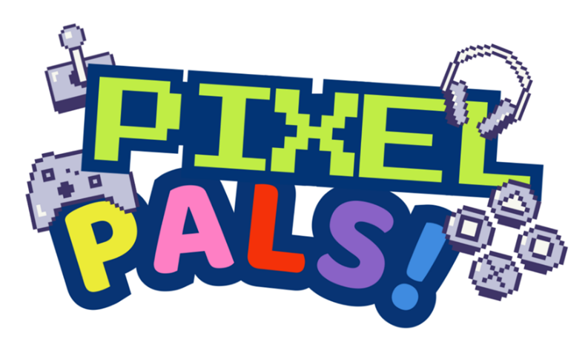

2. Project Description

2.1 Project Overview
PixelPals is a website aimed at promoting appropriate technology to parents and children. The initiative addresses concerns over physical and cognitive effects of prolonged screen time-posture, hearing, vision, and fine motor skills (Elghomati et al., 2022). PixelPals offer a range of ergonomically designed accessories, including adaptive keyboards and mouses, supportive seating, volume-sensitive headphones, and screen-time charts.

2.2 Vision and Objectives
The aim is to reduce physical strain and stunting of motor skills, educate families on safe and sustainable device habits and promote inclusive, user-centred designs aligned with developmental needs.

2.3 Target Audience
PixelPals' target audience is parents and children aged 3 to 12. But due to the focus on ergonomics, PixelPals can support elderly and disabled users, making the design versatile and expansive.

2.4 Technologies and Tools
PixelPals is going to use certain technologies and tools for the current design stage and for future development of the system, which is displayed in Table 2.4.1

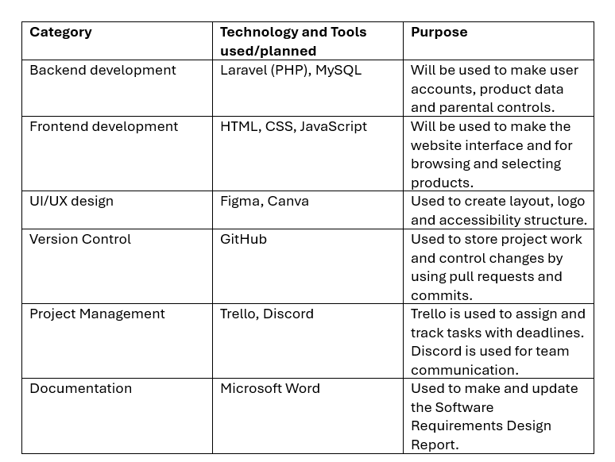
Table 2.4.1: Planned Technologies and Their Purpose

3. Functional Requirements

3.1 Introduction
Functional Requirements are based on what the system should do. This can be done by the usage of features, specific actions, and behaviours. Furthermore, it will make sure that the system allows the users to register, sign in, place orders and add parental control.

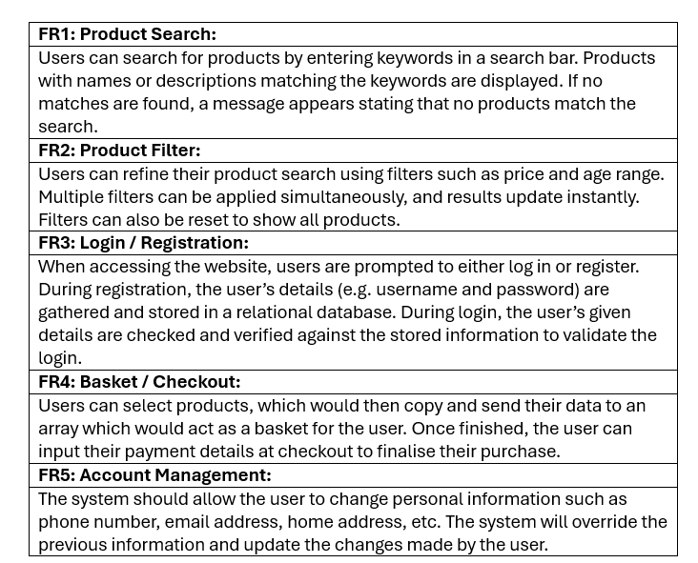
Table 3.1.1: Functional Requirement (FR) List

4. Non-Functional Requirements

4.1 Performance
The website must be able to load quickly, as it’ll prevent users from leaving the website. To boost perceived performance, there should be immediate visual feedback, for example, a button changing colour when clicked or showing a loading icon so that they are aware that their action has been registered and that the website is processing it.

4.2 Security

4.2.1 Technical Security
To protect user data, PixelPals will implement a Hypertext Transfer Protocol Secure (HTTPS) by using a valid TLS certificate to encrypt data sent between the browser and the website to prevent man-in-the-middle attacks.
Furthermore, Passwords must have a minimum of 8 characters, and they must include an uppercase letter, a lowercase letter and a number or special character. Old passwords can’t be reused, and passwords can't be shared, and if someone finds out the password, it must be changed.

4.2.2 Parental Control and Data Privacy
The PixelPals website is designed for children and parents, which means data protection must be prioritised at every stage of development. To achieve this, the system will include parental control features and account security to support safe and responsible use. The security requirements and how they will be implemented are stated below:
- Child data privacy: All information will be securely stored in the database to prevent unauthorised access, and only essential data will be collected from users.
- Parental control access: Parents will have access to screen time rules for children.
- Password security: Passwords will be hidden on screen during login, and the system will prevent children from giving their passwords to others.
- Access permissions: Only authorised team members will be able to modify or update sensitive product or system information.
Overall, these measures will keep the system suitable for children while giving parents reassurance and control over their child’s digital wellbeing.

4.3 Usability and Accessibility
The PixelPals website is designed to be easy to use for children and parents. It follows key UX principles, which include clear navigation, hierarchy and accessibility. Pages have a consistent theme, with high contrast and readable fonts, good for those with cognitive needs.
The interface will be tested on different devices to make sure it functions. Accessibility tools like WAVE and axe DevTools will screen-reader compatibility, along with manual checks to confirm keyboard navigation. Each step will make sure the website meets WCAG 2.1 accessibility standards.

4.4 Maintainability
The PixelPals system is designed to be easy to update and expand in the future. Table 4.4.1 shows how the team has used organised and traceable development practices to support all continuous improvements.

Table 4.4.1: Maintainability principles and their application in PixelPals
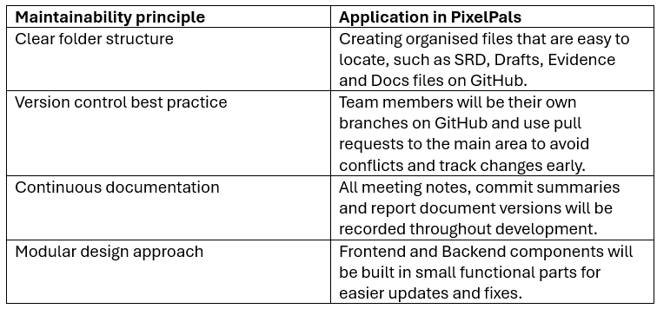
To summarise, all these approaches will support long-term maintenance by allowing new features and bug fixes to be added without difficulty.

5. Use Cases and Design

5.1 Use Cases-Products
The product use case diagrams show how users interact with the catalogue by viewing product details by searching, and filtering. The use case diagrams are linked to the product search and filtering functional requirements, which are mentioned and described in section 3.2.

Diagram 5.1.1: Product use case diagram (search and view).
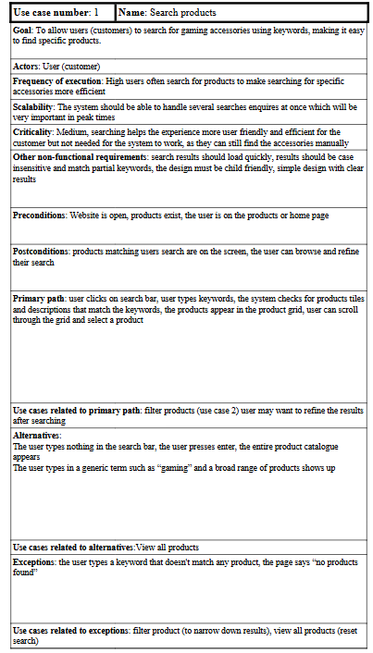

Diagram 5.1.2: Product use case diagram (filtering and selection).
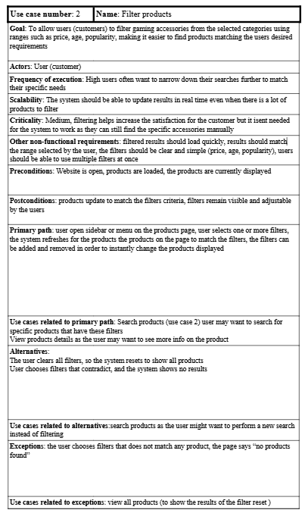

5.2 Use Cases – Login & Basket
Use case diagrams linking to login and basket show how users should sign in, sort out their basket and checkout. The diagrams below support the functional requirements for login, basket and account management.

Diagram 5.2.1: Login use case overview.
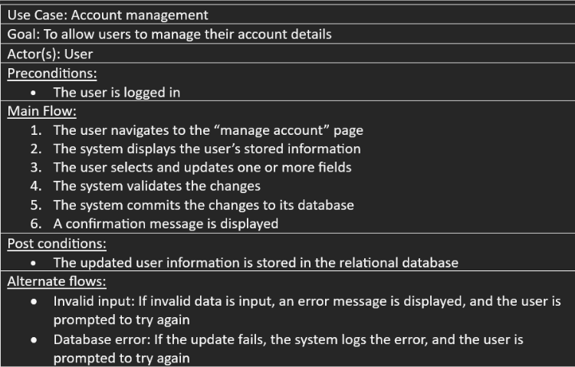

Diagram 5.2.2: Basket management use case.
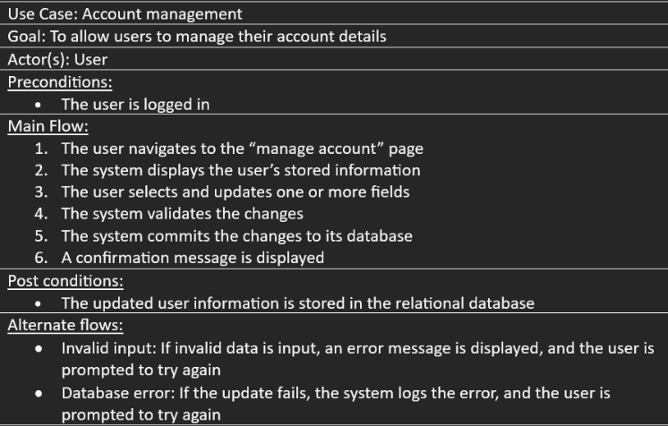

Diagram 5.2.3: Login and basket interaction flow
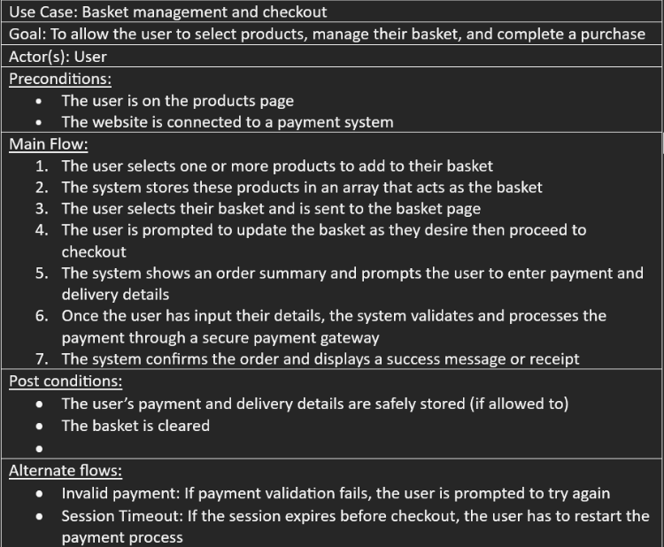

5.3 Interface Wireframes
The low-fidelity homepage wireframe is made using Figma, focuses on layout and structure. As mentioned in 4.3, it shows the placement of elements such as the navigation bar, hero banner, product grid, and header. Each section is clearly annotated to explain its purpose.
The high-fidelity wireframe, also created in Figma, represents the final visual design of the homepage and shows the vibrant colour palette that reflects PixelPals' brand identity.

Diagram 5.3.1: Low-fidelity homepage wireframe
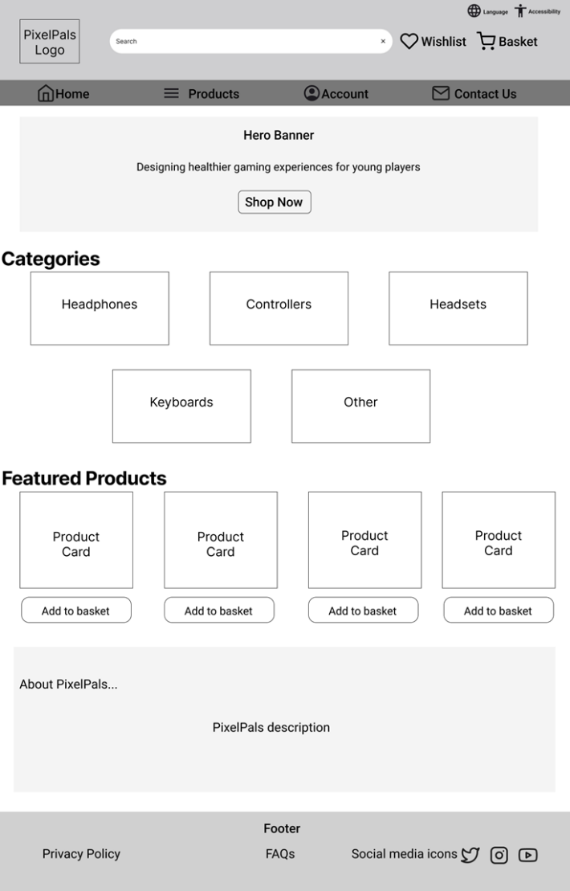

Diagram 5.3.2: High-fidelity homepage wireframe
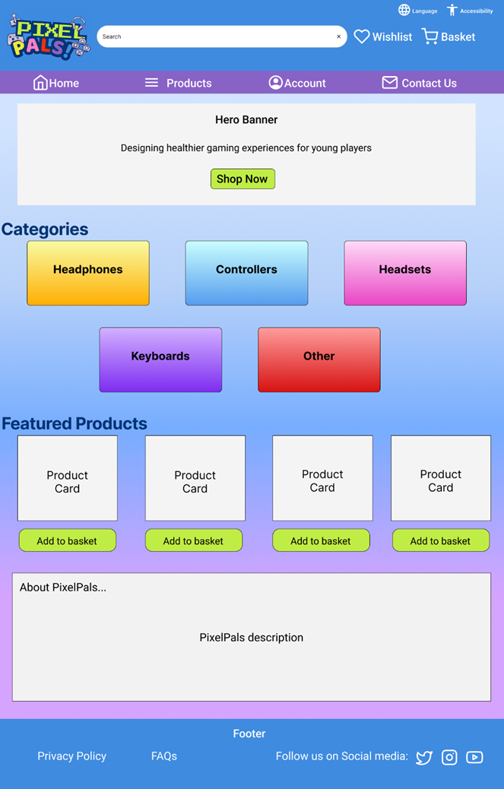

5.4 Database Design (ERD)

Diagram 5.4.1: showing ERD
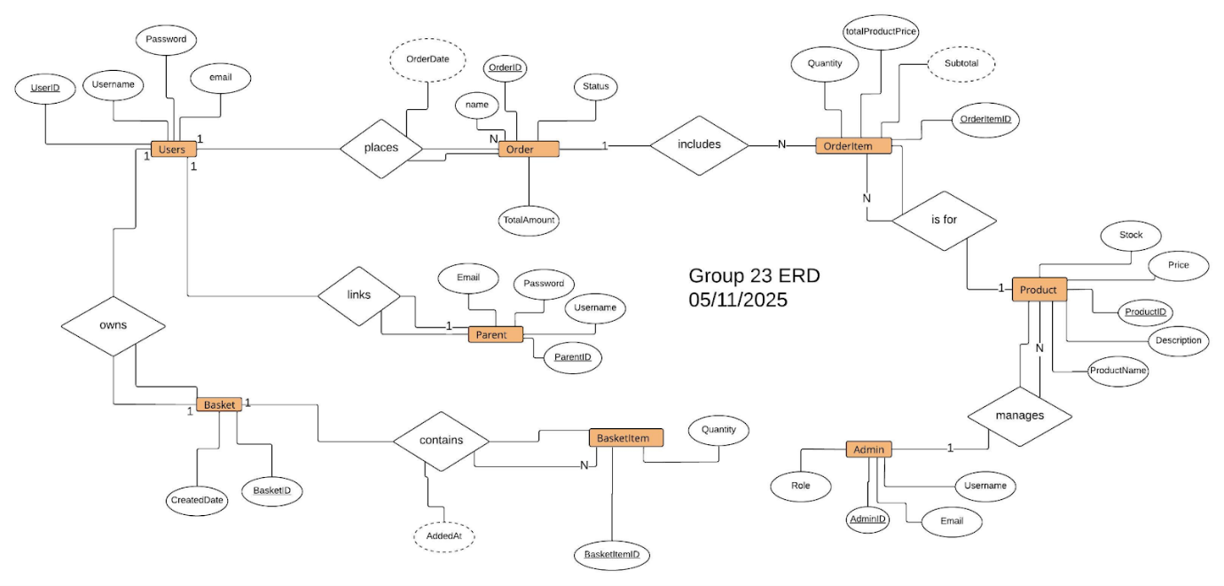
This ERD shows how users, orders, products, and related entities connect within the system. Entities are shown as rectangles, relationships as diamonds, and attributes as ovals—with underlined primary keys and dashed relationship attributes. Users can make multiple orders containing items linked to admin-managed products. Each user also has a basket with tracked items, and parents are linked for account management. The ERD maintains a clear, consistent, and efficient database structure.

5.5 Flow Diagrams (Admin/User Journey)
This user flow diagram shows the path going from landing on the homepage to then browsing products, adding the products to the basket and then checking out. The admin flow diagram shows the administrator actions, which include logging in, managing products and reviewing the orders.

Diagram 5.5.1: User journey flow through the main website pages.
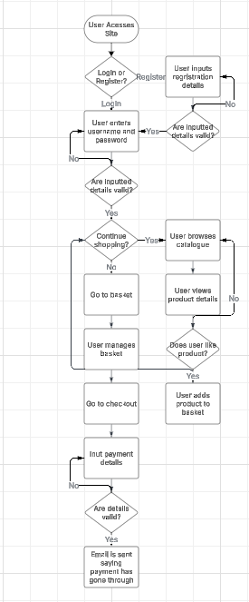

Diagram 5.5.2: Admin flow for managing products and orders.
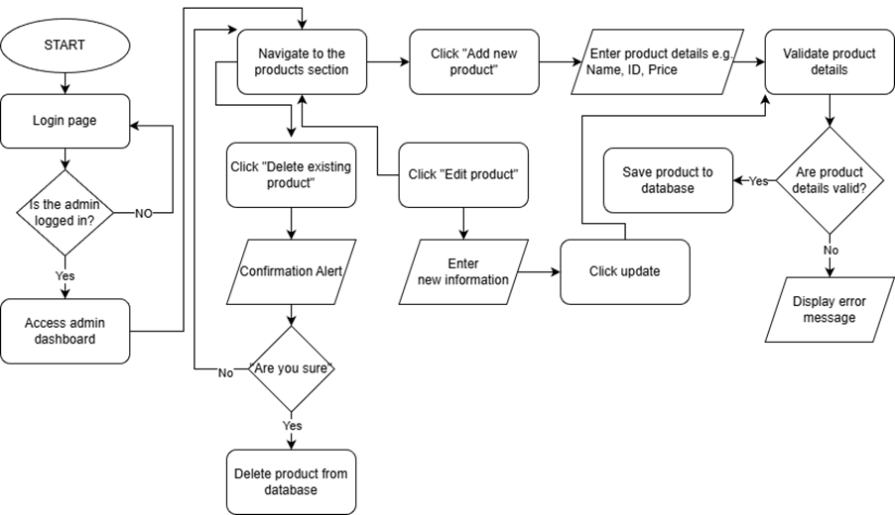

5.6 Site Map
The site map visualises the overall structure of the PixelPals website, including the homepage, product categories, login and account pages, and any parent-specific sections. It ensures that navigation paths are clear and that key pages are easy to access.

Diagram 5.6.1: showing a simple site map
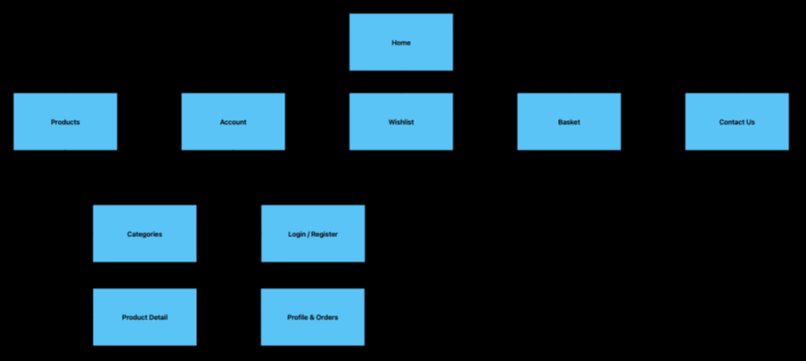

6. Project Management

6.1 Development Methodology
The PixelPals team adopted Agile methodologies to manage the development of the software requirements and design (SRD) report and to plan the structure of the PixelPals prototype.
The workload was structured into weekly sprints, with deliverables including drafted report sections from each team member and progress meeting notes. This approach targets issues specifically to ensure accuracy and efficiency, and allows for easy traceability.
Each week consisted of a weekly progress meeting, a plan for next week's progress meeting, individual task assignments via Trello, and updates on GitHub. The project manager ensured deadlines were realistic and that the progress aligned with the mark schemes. Team members were encouraged to communicate transparently and document each change for accountability and version control.
The cycle of planning, developing, reviewing and integrating mirrors Agile workflows in industry, and the team chose this method since it allowed adaptability and continuous improvement, which is important in software development.

6.2 Project Planning Tools (Trello)
The PixelPals team used Trello to plan, track and manage tasks for the Software requirements and design phase. The structure of Trello was visual, which kept the team time aware and organised.
The Trello Board was made up of lists, task cards and meeting cards. Each card was colour-coded by role, had due dates and checklists, and was moved across lists depending on its progress status. Table 6.2.1 explains the purpose of each list in Trello.

Table 6.2.1: Trello Lists and Their Purpose
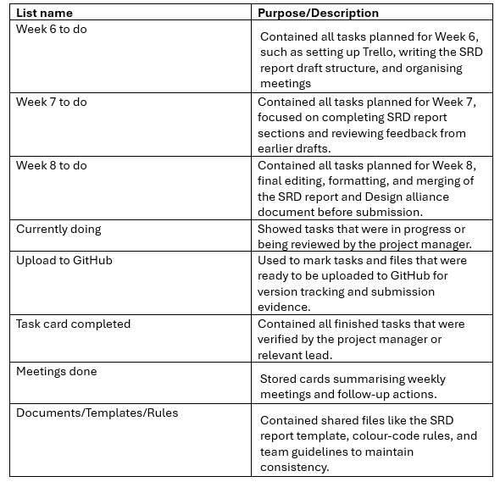
A link to the full Trello board is provided below for reference: https://trello.com/b/MgNq9DBY
Trello board screenshots are stored in the GitHub repository under “Evidence/ Trello Screenshots”, and the full Trello layout showing all team roles and weekly progress is displayed in Appendix G (Figure G1).

6.3 Communication and Collaboration
The team communicated through Discord and in-person meetings. Emails were used as a formal reminder of deadlines, tasks, and meetings. Also, the team is divided into sub-groups that collaborate and overlap in their work. This combination assured consistent collaboration, availability, and understanding of task completion.

6.4 Version Control and File Management (GitHub)
The team used GitHub to store report drafts, evidence of project commitment and to track updates and changes. In terms of the process, each team member would make their own version of the branch and create commits of what was added or changed. When the update was finished, a pull request was sent to the project manager to review before merging it into the main branch.
The repository was named “Team 23 PixelPals” and was organised into clear folders:
- Term1A/: To keep GitHub submissions organised by term. It contains the Software Requirements Design (SRD) report, Docs and Evidence folders.
- SRD report/: SRD drafts from each member, submission plan, and final version of the SRD report.
- Design alliance/: Contains the Design Alliance document
- Evidence/: Trello screenshots, meeting notes, and commit summaries
This structure kept the project organised and traceable. Notes on commits and pull requests are stored in “Evidence/ GitHub commits” within the repository.
The GitHub repository link is provided below for reference: https://github.com/maeesa-ali/team_23_pixelpals

6.5 Design and Technical Overview
The design of PixelPals focuses on creating child-centred shopping experiences that also appeal to parents. Saturated colours like Blue and Purple complement the logo. Lime green highlights key interactive elements, such as buttons like “Add to Basket” and “Shop Now,” encouraging engagement from users. The category tiles complement the logo with gradients to give a dynamic feel. Figma was used to design the wireframes, and Canva was used to create the logo and visuals.
The website will be developed using Laravel and MySQL to handle both the front-end layout and the server-side logic. PHP makes the website dynamic, for product listings and user interactions to be managed efficiently. The structure in the Figma wireframes will be implemented using responsive web design principles, ensuring compatibility across various screen sizes and devices.

7. Conclusion
The development of the PixelPals Software Requirements and Design (SRD) document shows the team's ability to plan, collaborate and design a child-centred platform. Using programming methods such as Agile and tools such as Trello, GitHub and Figma, whilst maintaining communication, has allowed the Team to progress efficiently through the project. The report provides clear instructions for future iterations using functional and non-functional requirements. Overall, PixelPals successfully combines creativity, technical planning and user-focused design to support healthy digital habits for children.

Appendices

Appendix A – Entity Relationship Diagram


Appendix B – Admin Flow Diagram


Appendix C – Wireframes and Brand Design
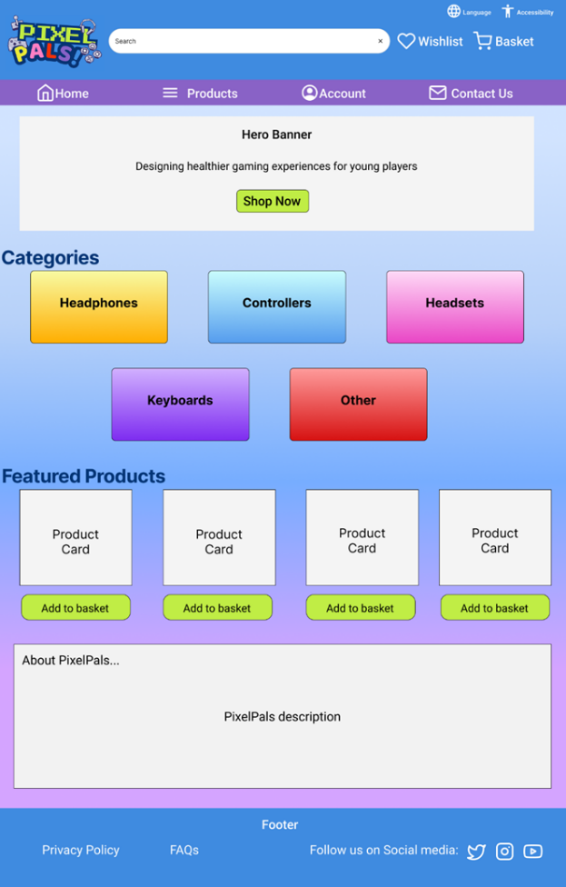
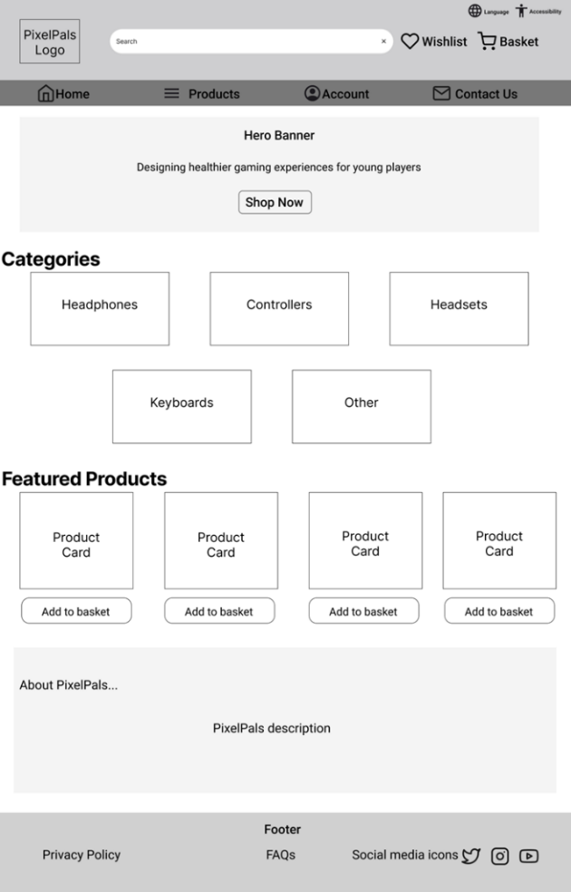

Appendix D – User Journey Diagram


Appendix E – Site Map


Appendix F – Trello Board Structure and Workflow
Figure G1: PixelPals Trello Board Overview (Weeks 6–8)
This figure shows the team’s Trello board used to plan and track SRD report progress.
Each list organised weekly tasks, deadlines, and responsibilities, and
colour-coded cards displayed each member’s role and task status, supporting collaboration and clear time management.
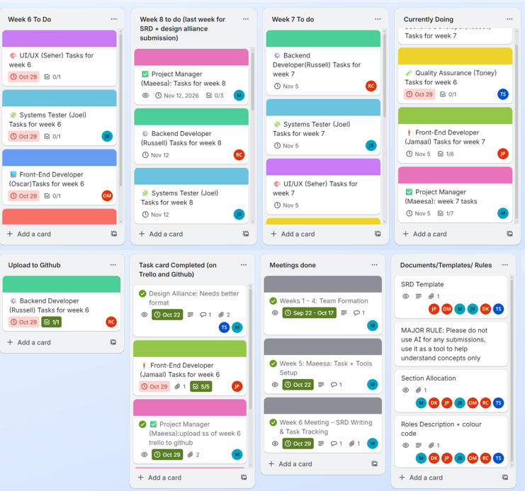

8. References
Elghomati, A., Korhan, O., Sekeroglu, B. & Dogruyol, K. (2022) ‘Short-Term Impacts of Mobile Touch-Screen Device Use on Musculoskeletal Disorders During Covid-19 Pandemic: Risk Assessment Modelling and Verification’, South African Journal of Industrial Engineering, 33(2), pp. 62-77. doi: 10.7166/33-2-2598.

